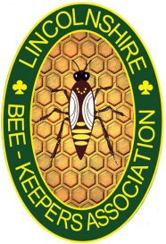
Lincolnshire Beekeepers’ Association

Spring Lecture
2pm Saturday 10th March 2018

Riseholme College Showground Campus
Tillbridge Lane (Access old gate 3) Lincoln, LN1 2ZR

Ancient Beekeeping: Looking to the past, looking to the future
Speaker
Chris Park

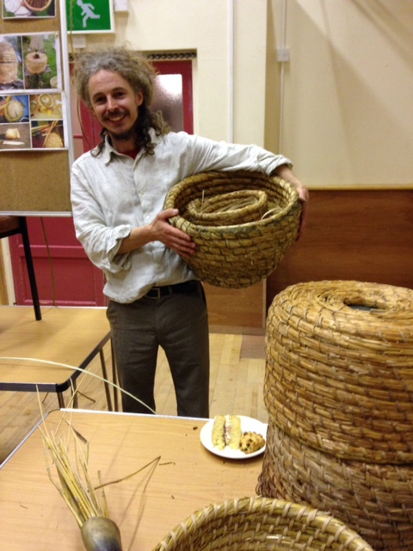

Free to all LBKA members

To be followed by refreshments and the Association’s AGM at 3.30pm

For further information and to reserve a seat, please contact:
Martin Robinson email: martinlbka@yahoo.com

